**MILESTONE 5- MIDDLEWARE BATCH**

**NAME:** T.MANIPRIYA

**EMPLOYEE ID:** 761131

**MAIL:** [Manipriya.T@cognizant.com](mailto:Manipriya.T@cognizant.com)

**LOCATION:** Siruseri, Chennai

**USER REGISTRATION:**

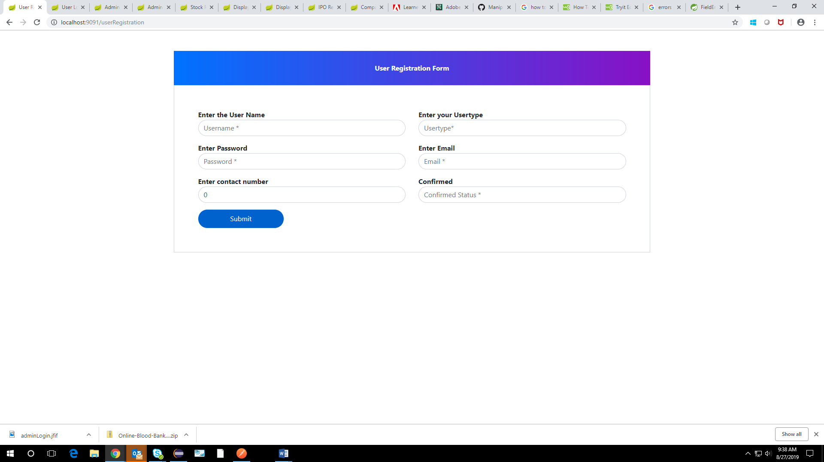

**USER REGISTRATION WITH VALIDATION:**

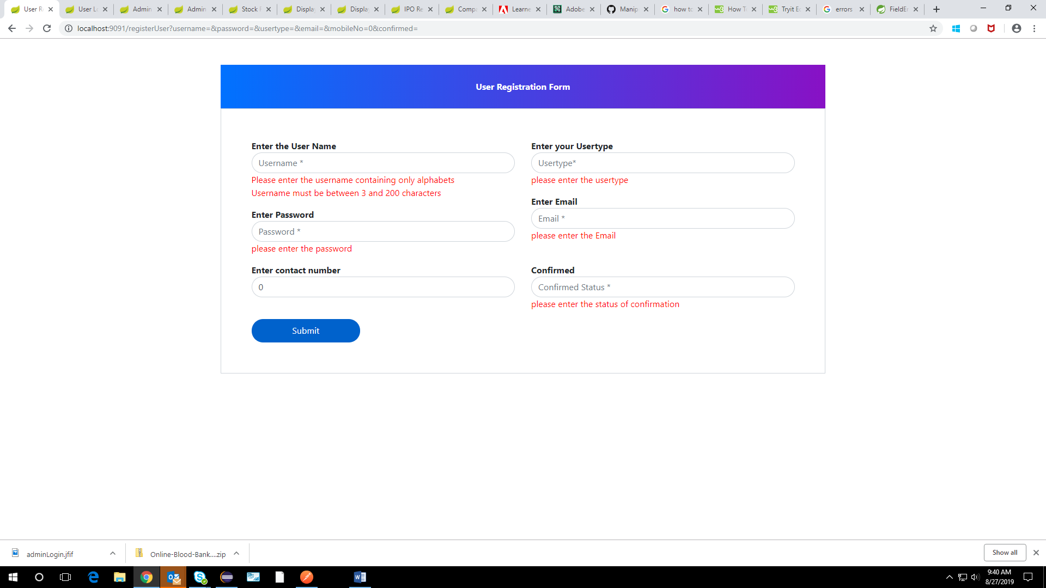

**ADMIN LOGIN:**

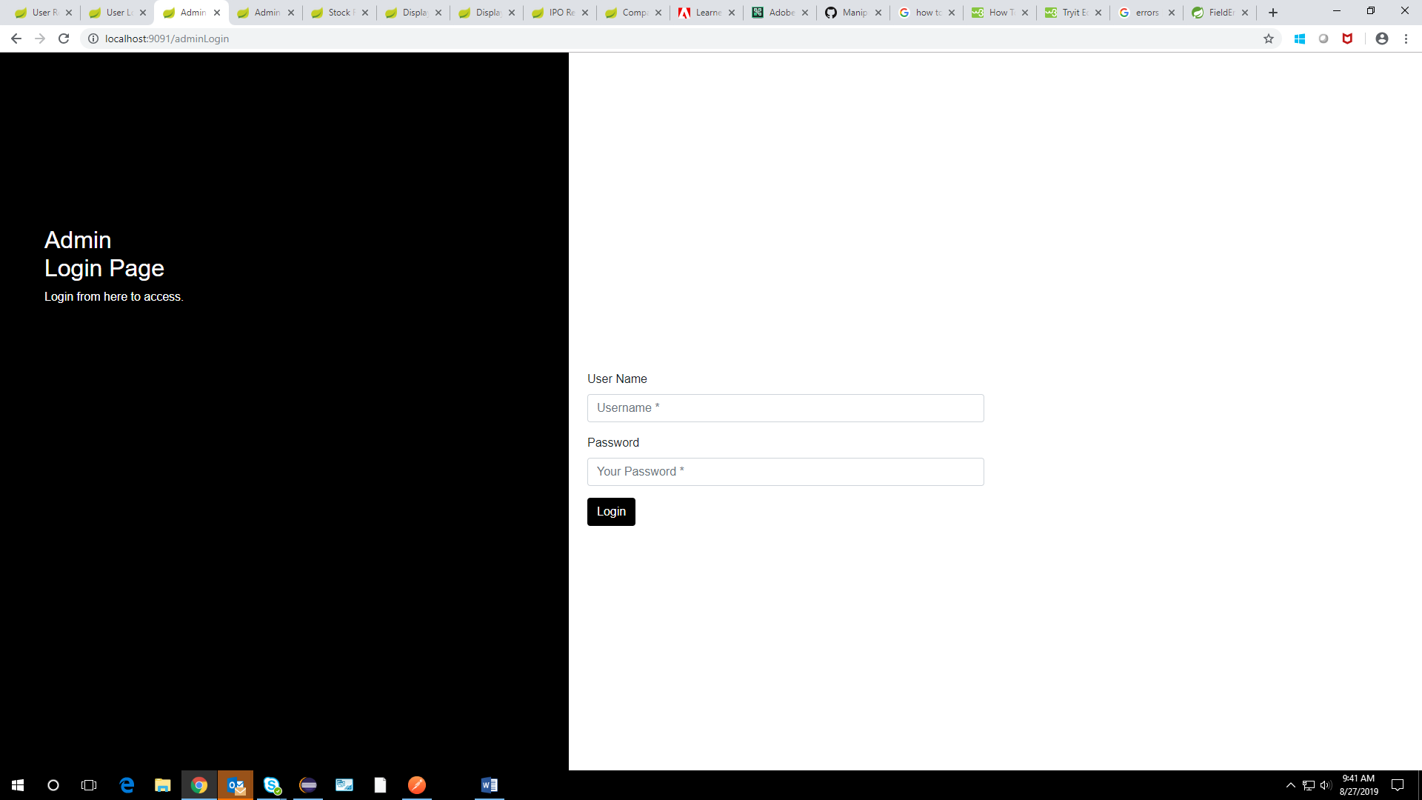

**USER LOGIN:**

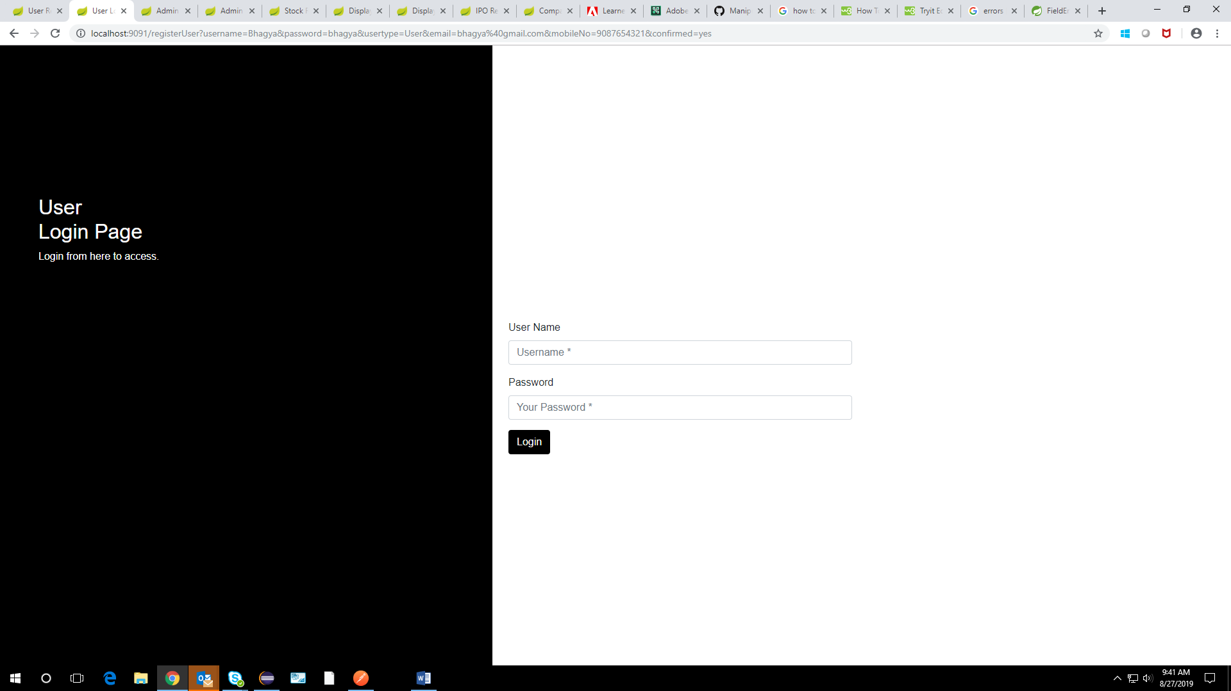

**ADMIN LANDING PAGE:**

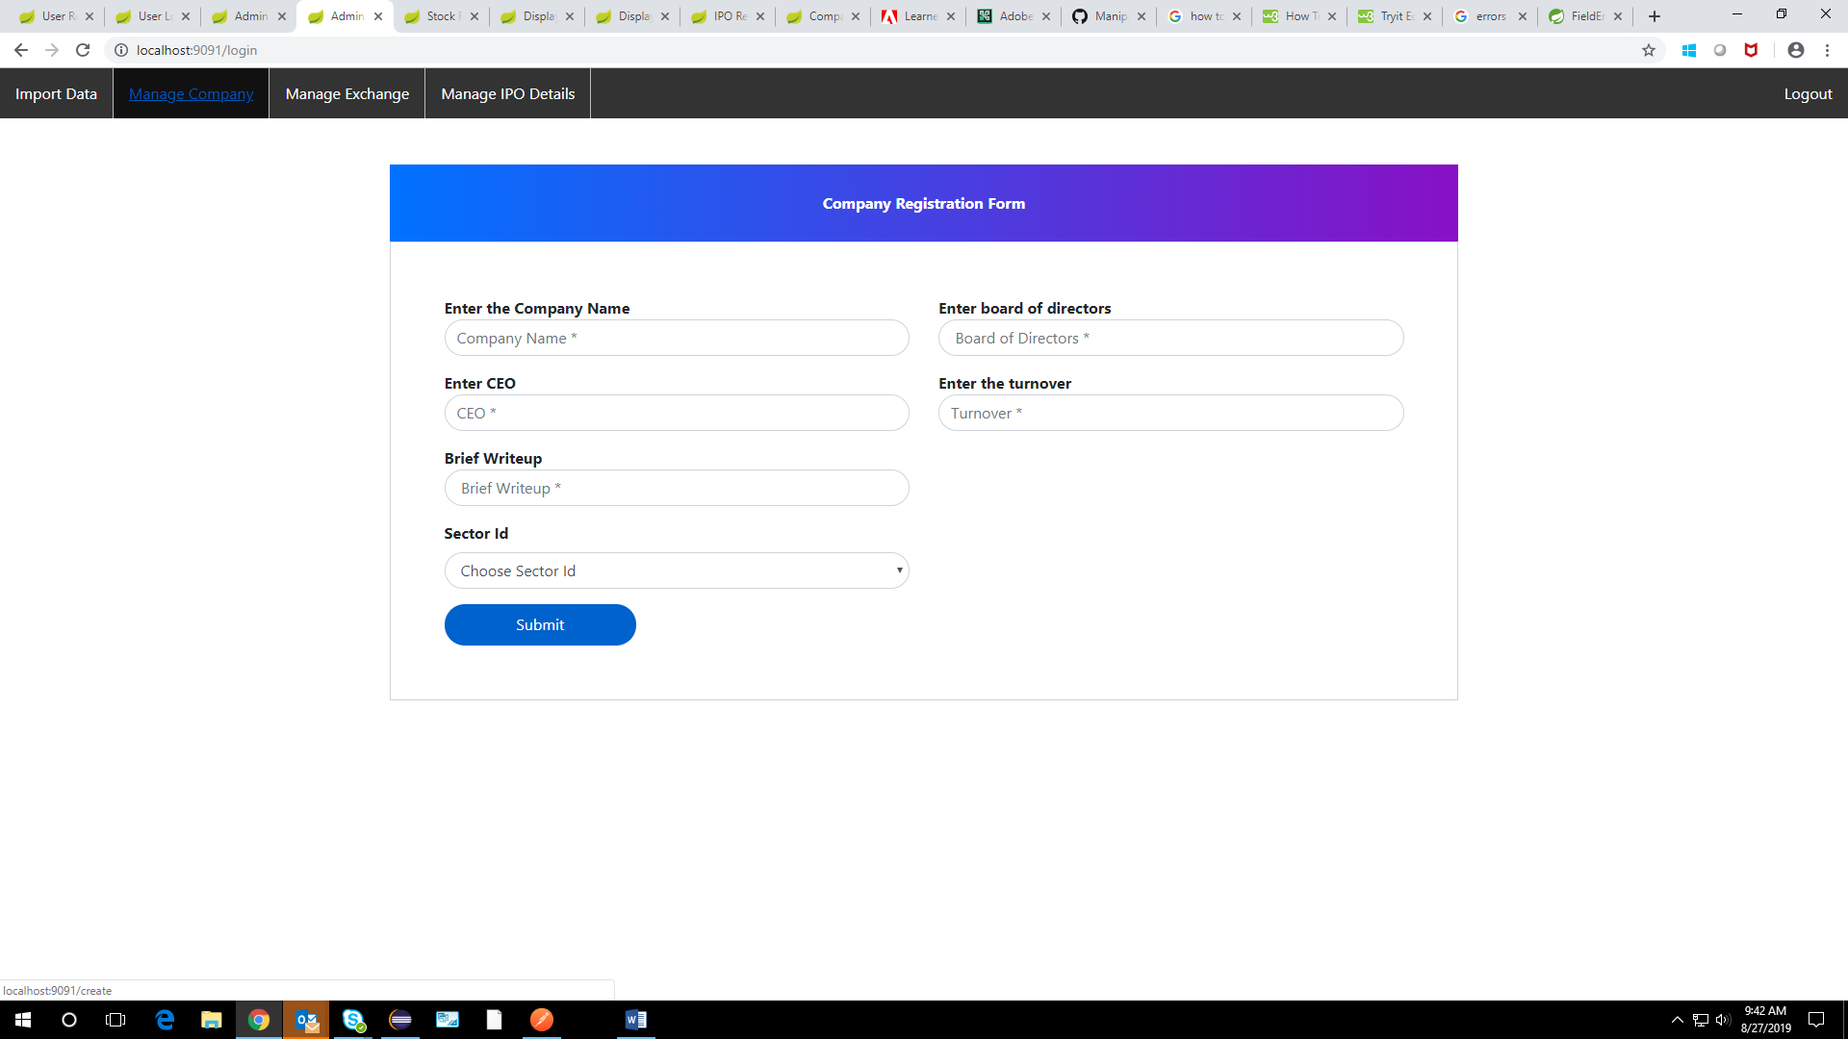

**MANAGE COMPANY FORM WITH VALIDATION:**

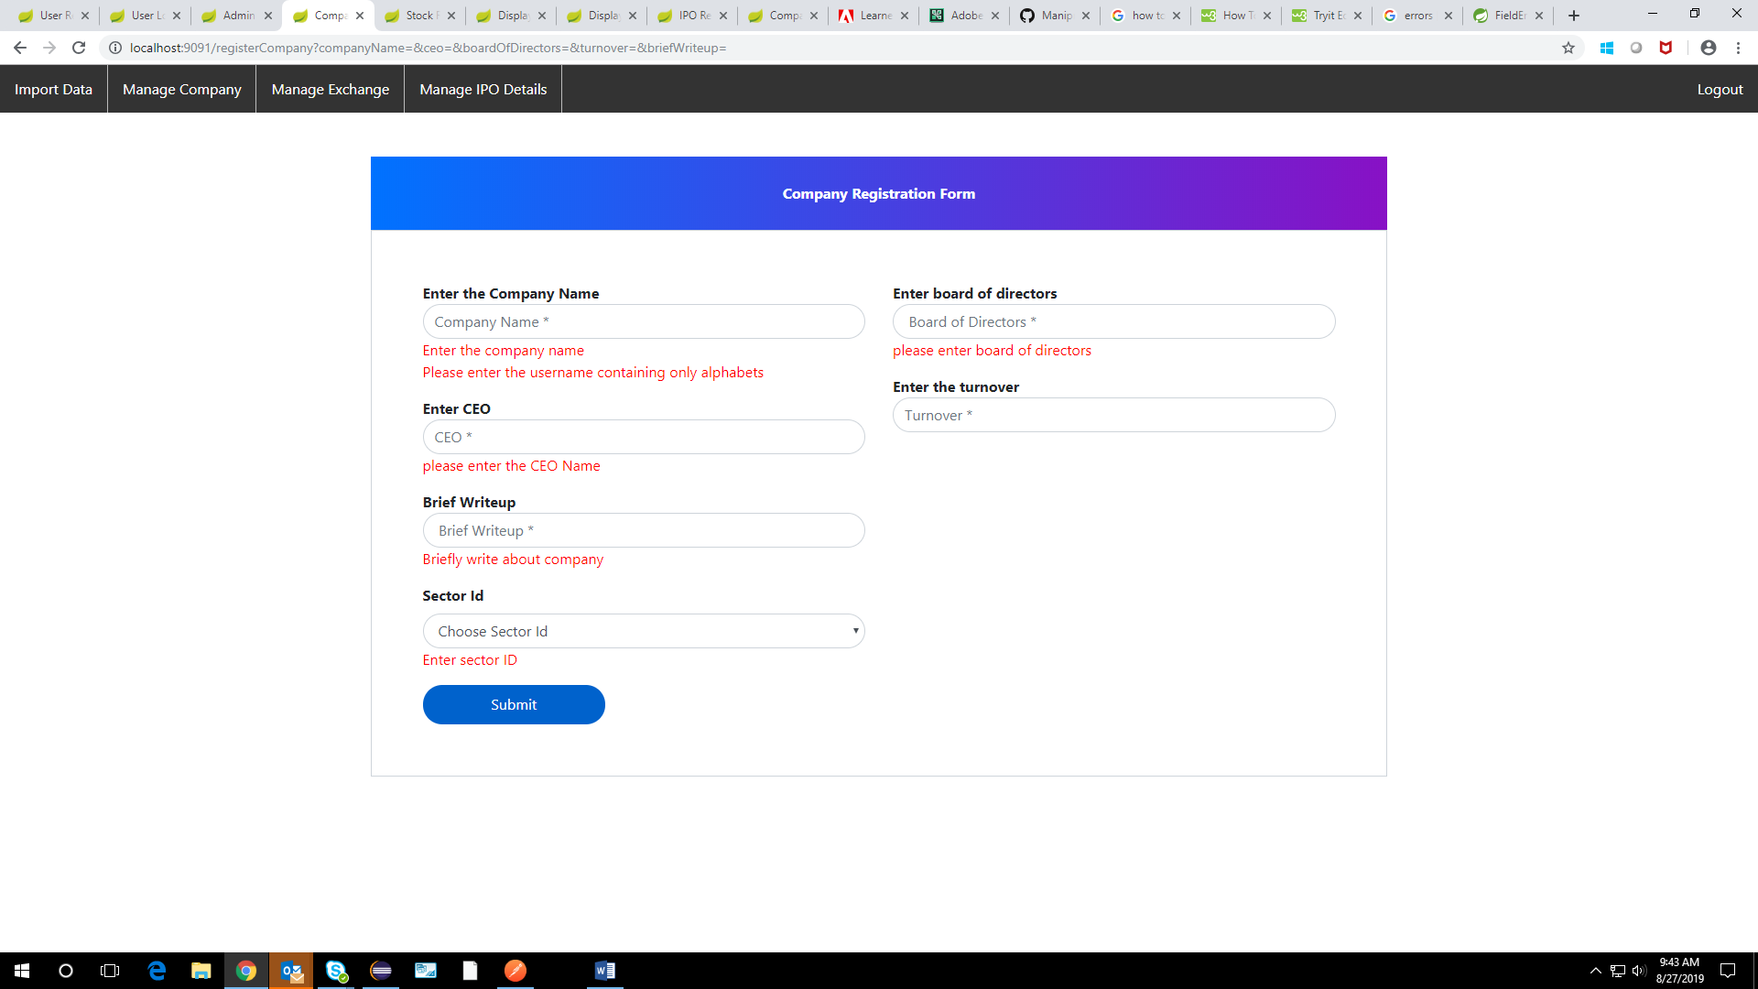

**DISPLAYING COMPANY DETAILS:**

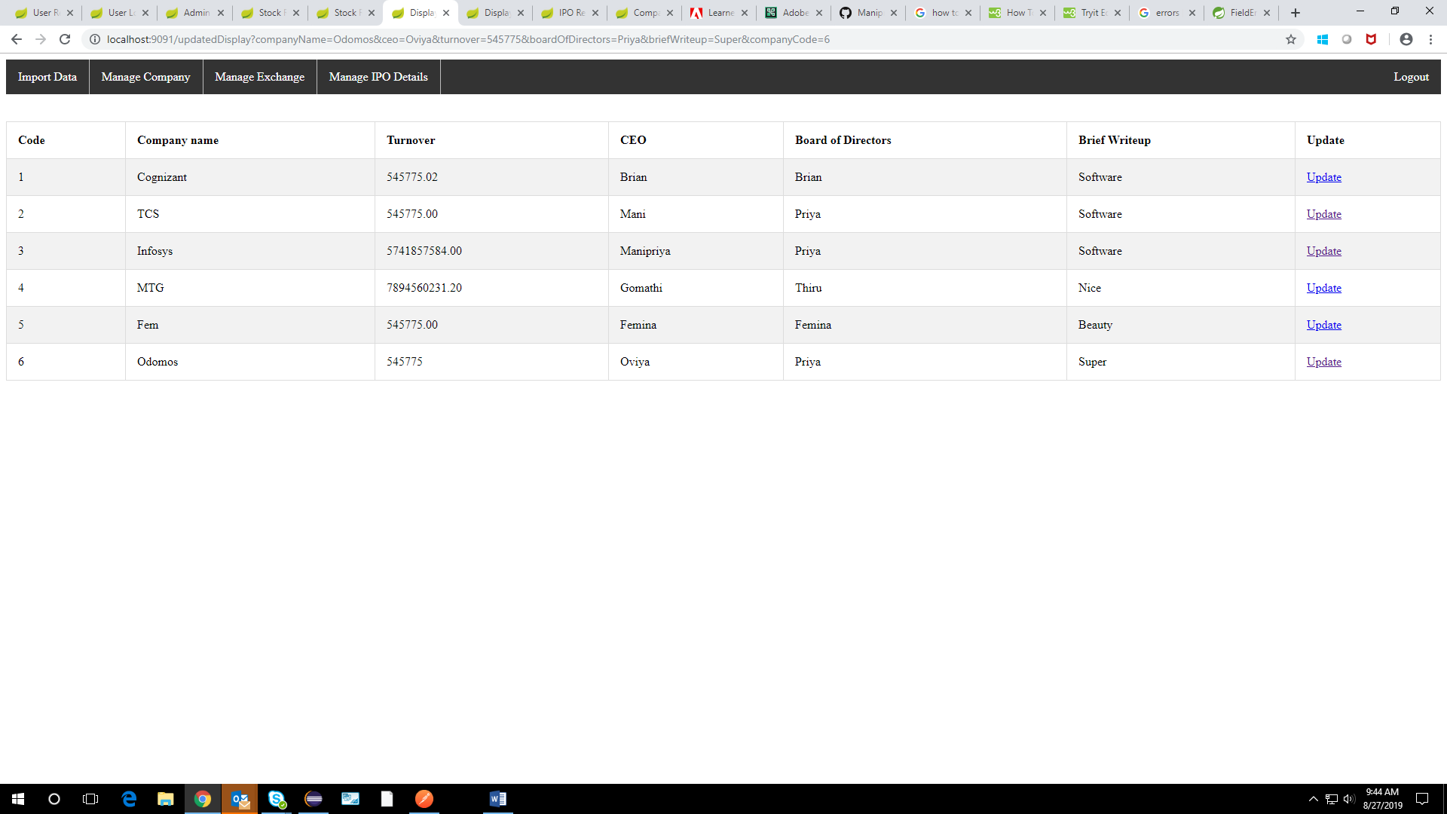

**UPDATING COMPANY DETAILS:**

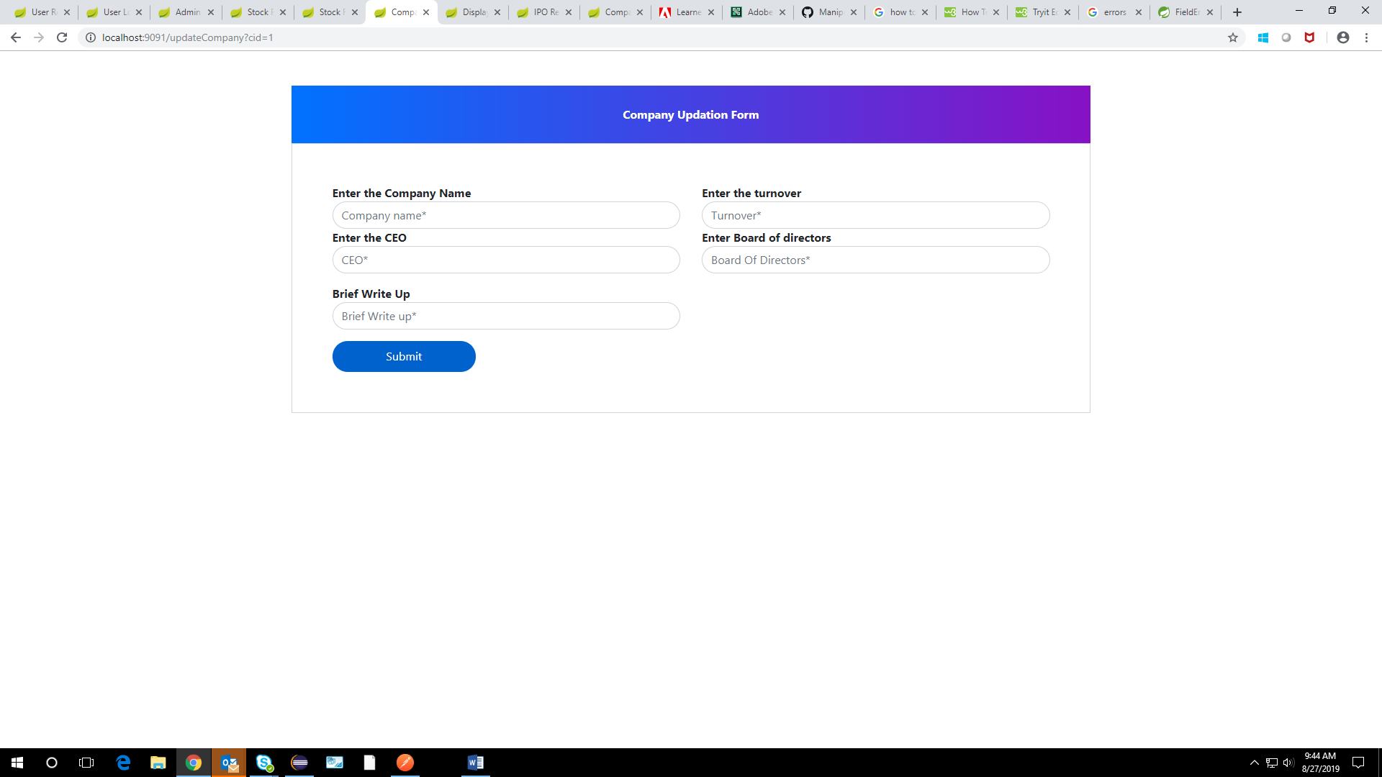

**MANAGE STOCK EXCHANGE:**

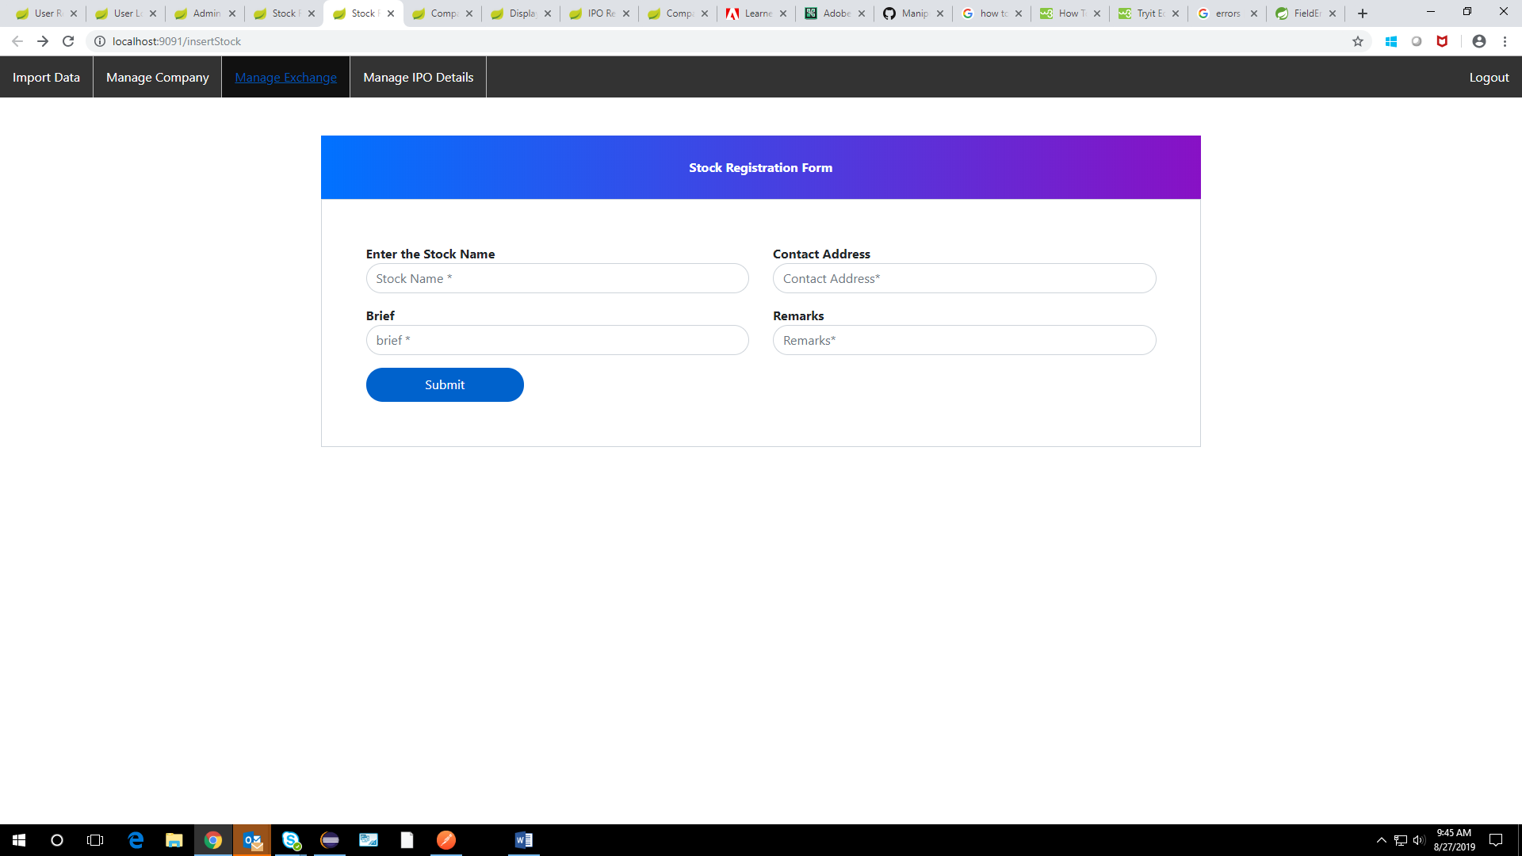

**STOCK EXCHANGE FORM VALIDATION:**

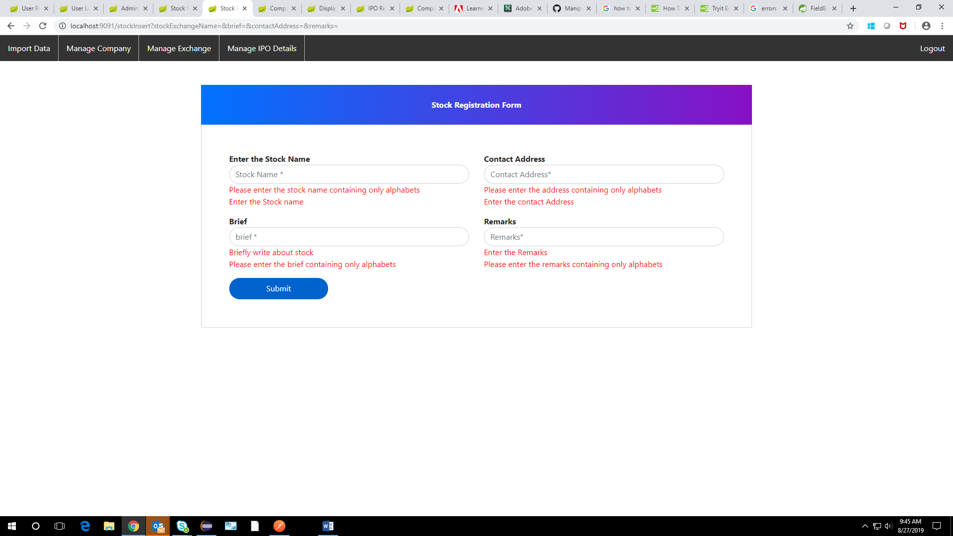

**DISPLAYING STOCK EXCHANGE DETAILS:**

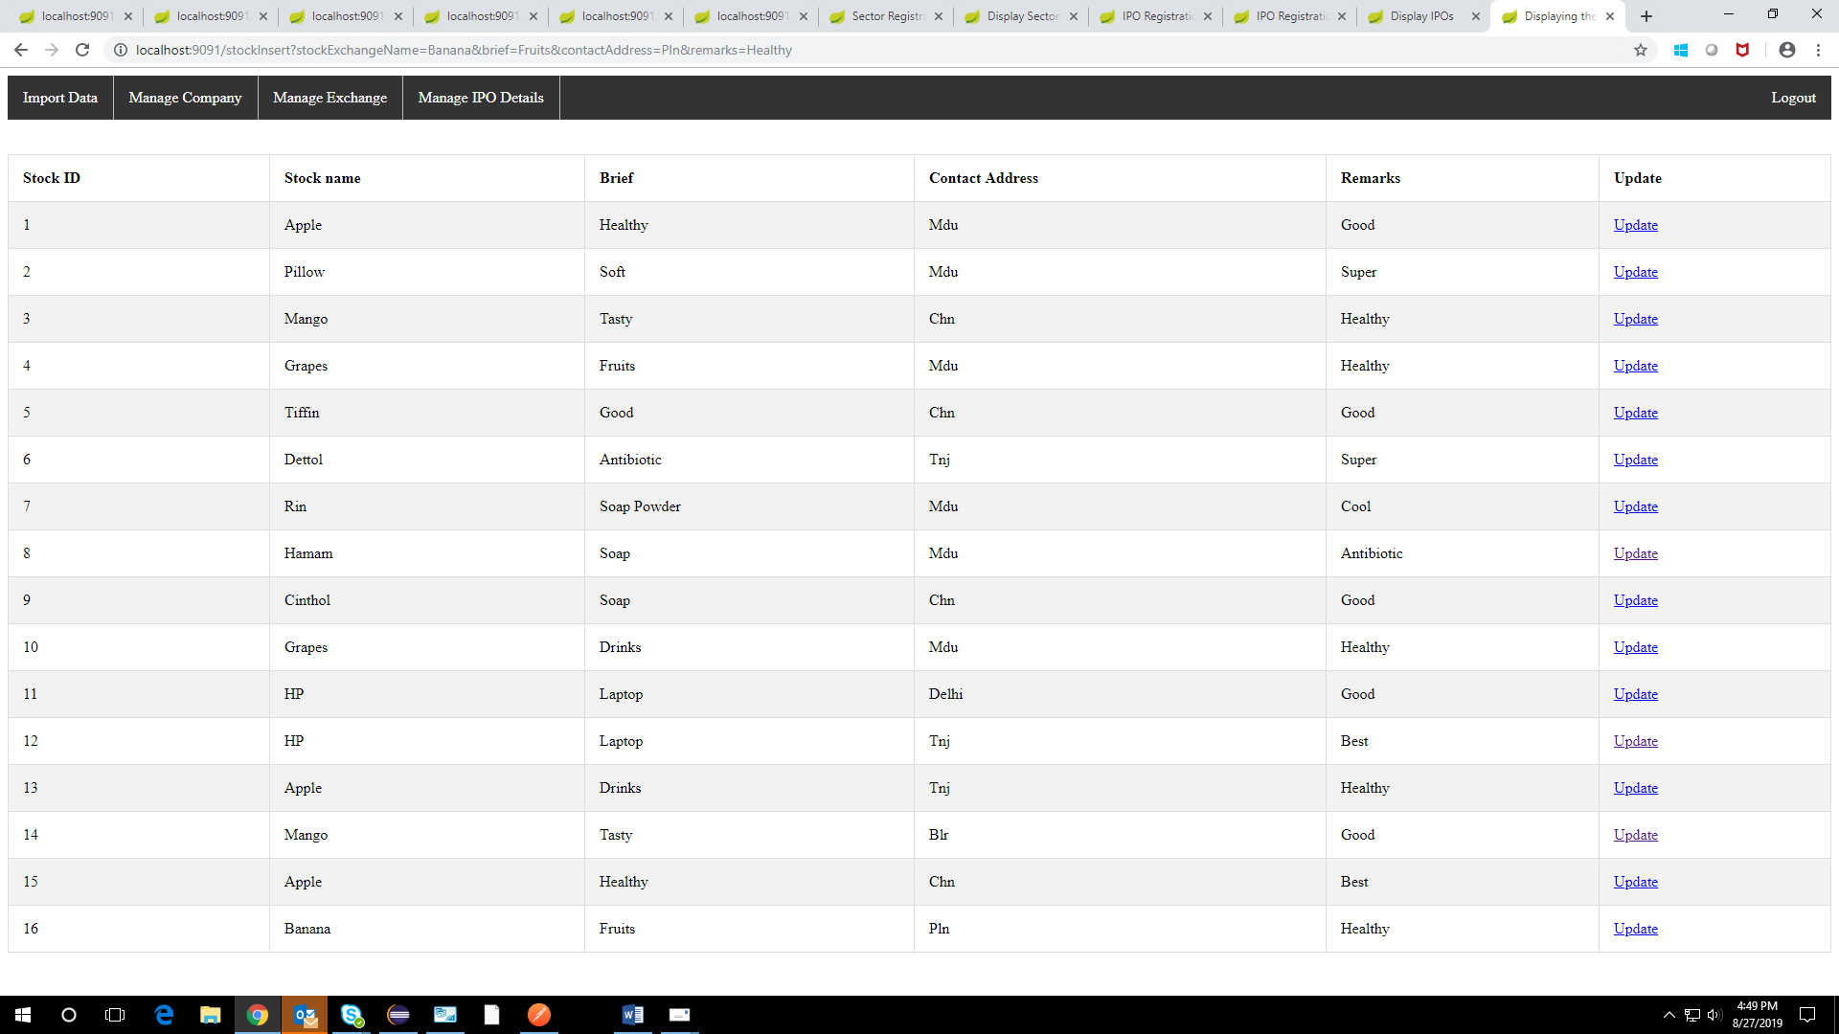

**UPDATING STOCK EXCHANGE DETAILS:**

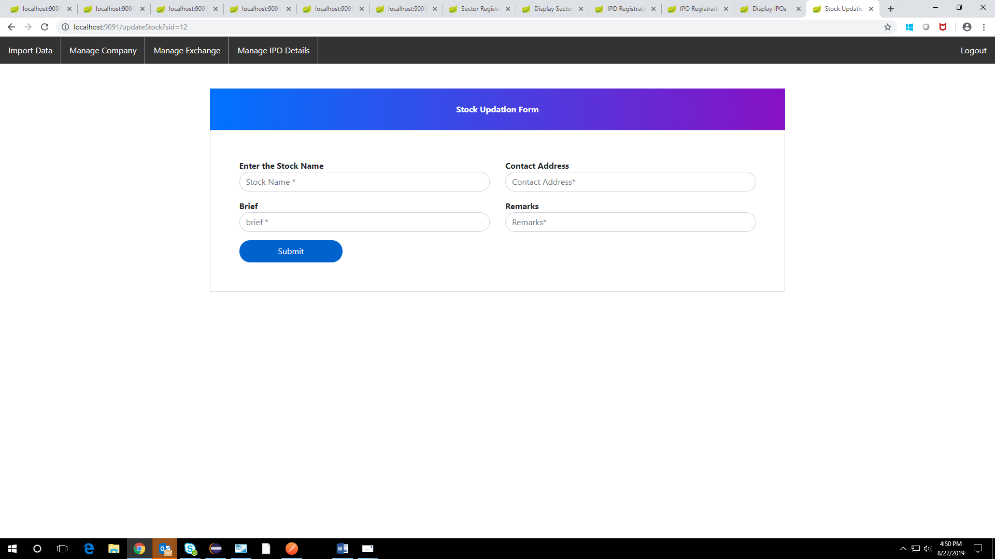

**MANAGING IPO DETAILS:**

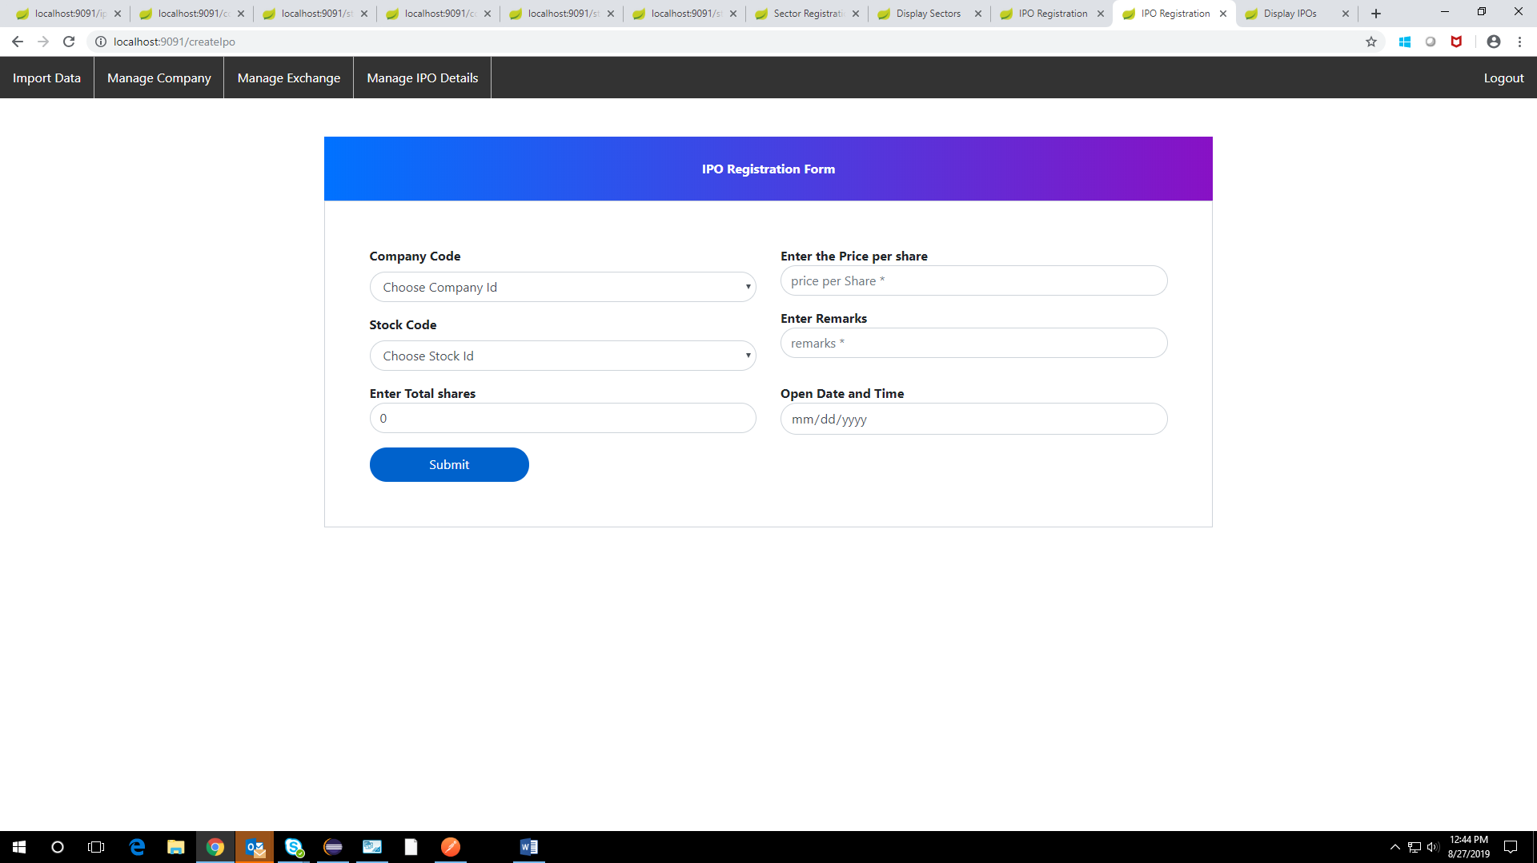

**IPO FORM WITH VALIDATION:**

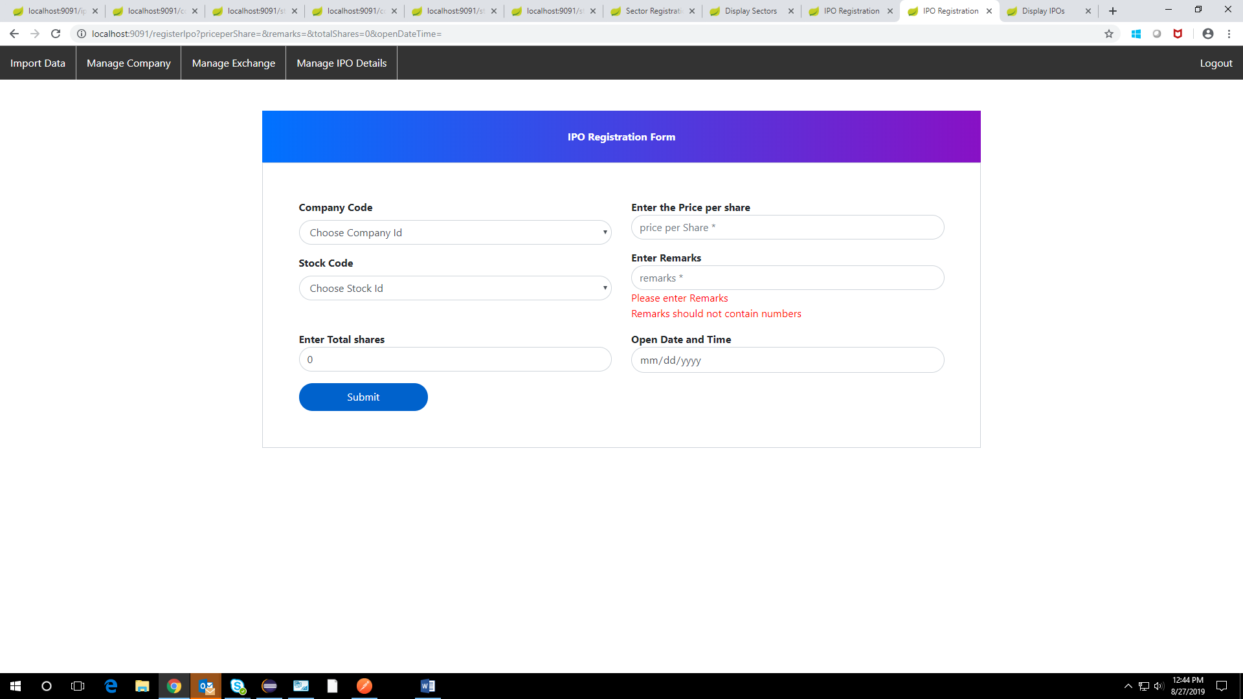

**DISPLAYING IPO DETAILS:**

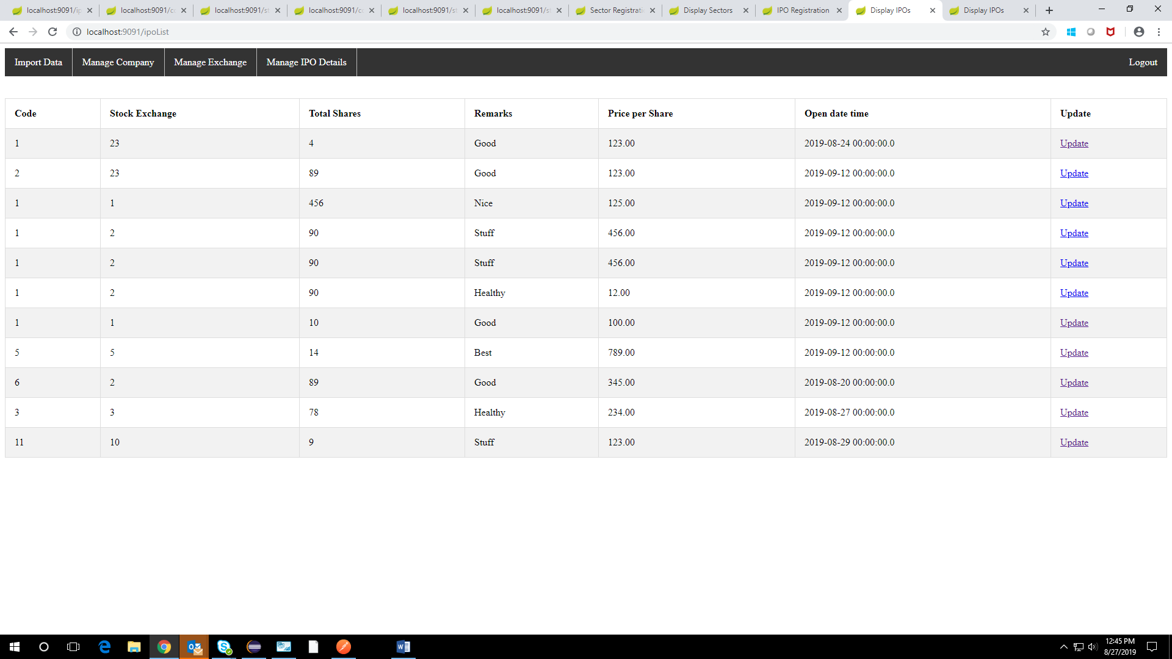

**UPDATING THE IPO DETAILS:**

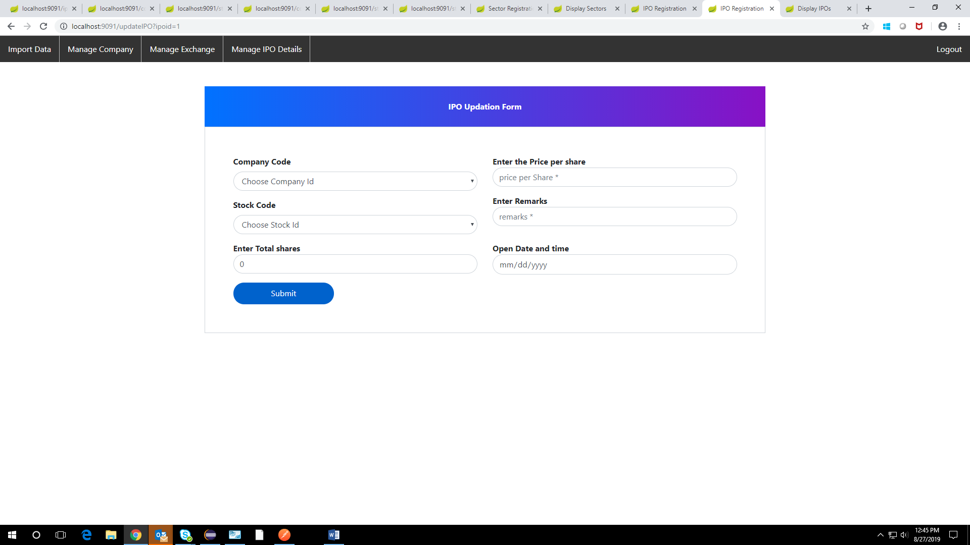

**SECTOR REGISTRATION:**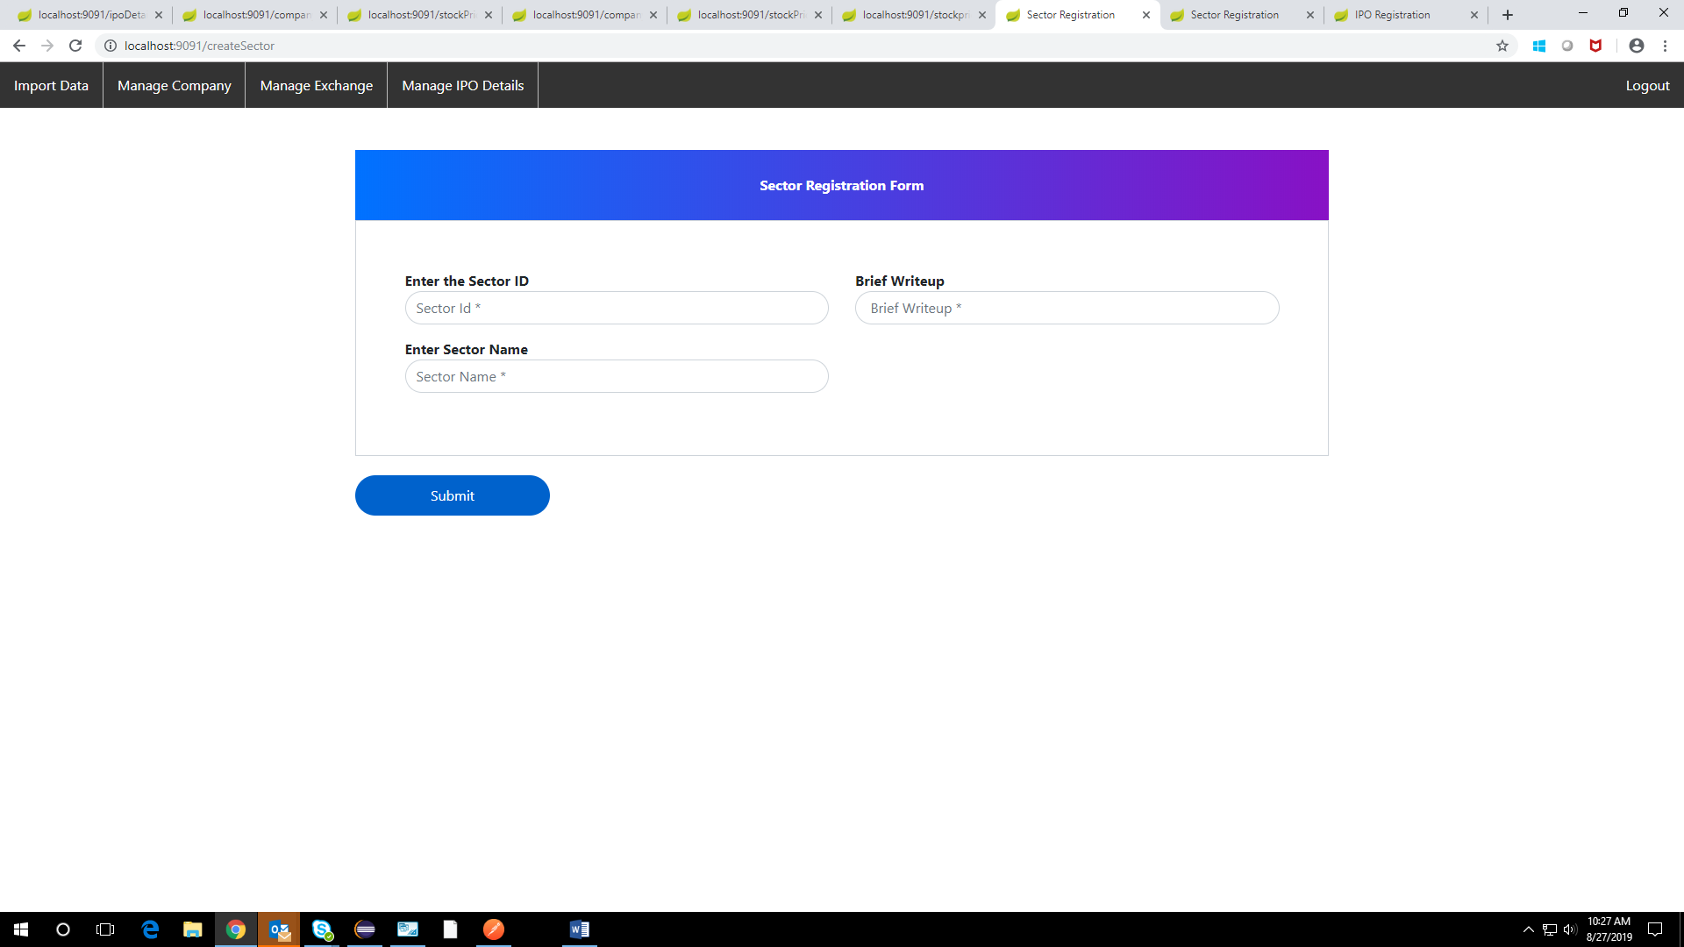

**SECTOR REGISTRATION WITH VALIDATION:**

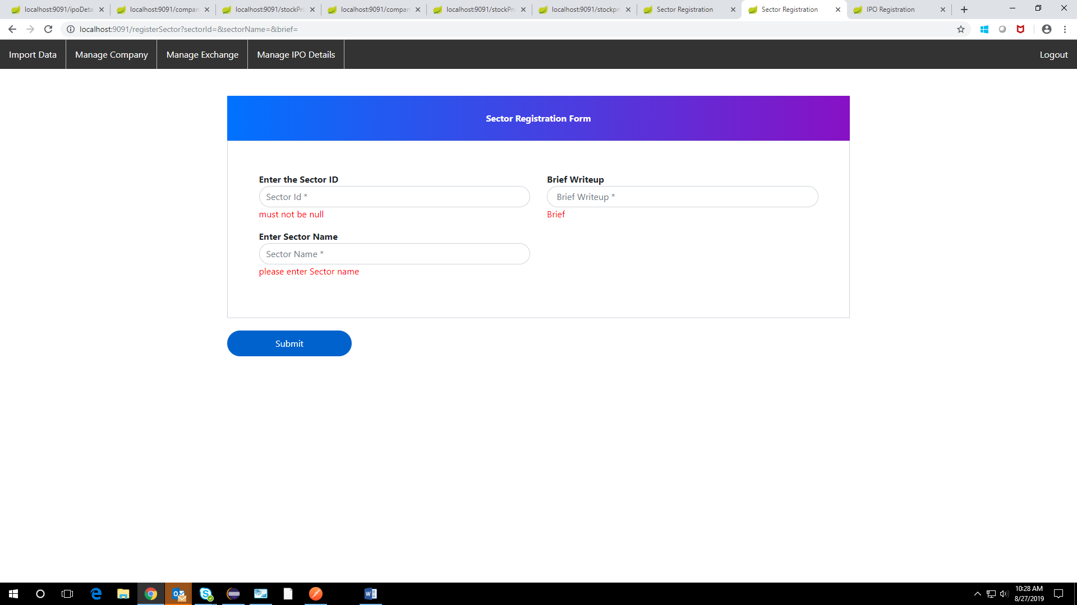

**DISPLAYING SECTOR DETAILS:**

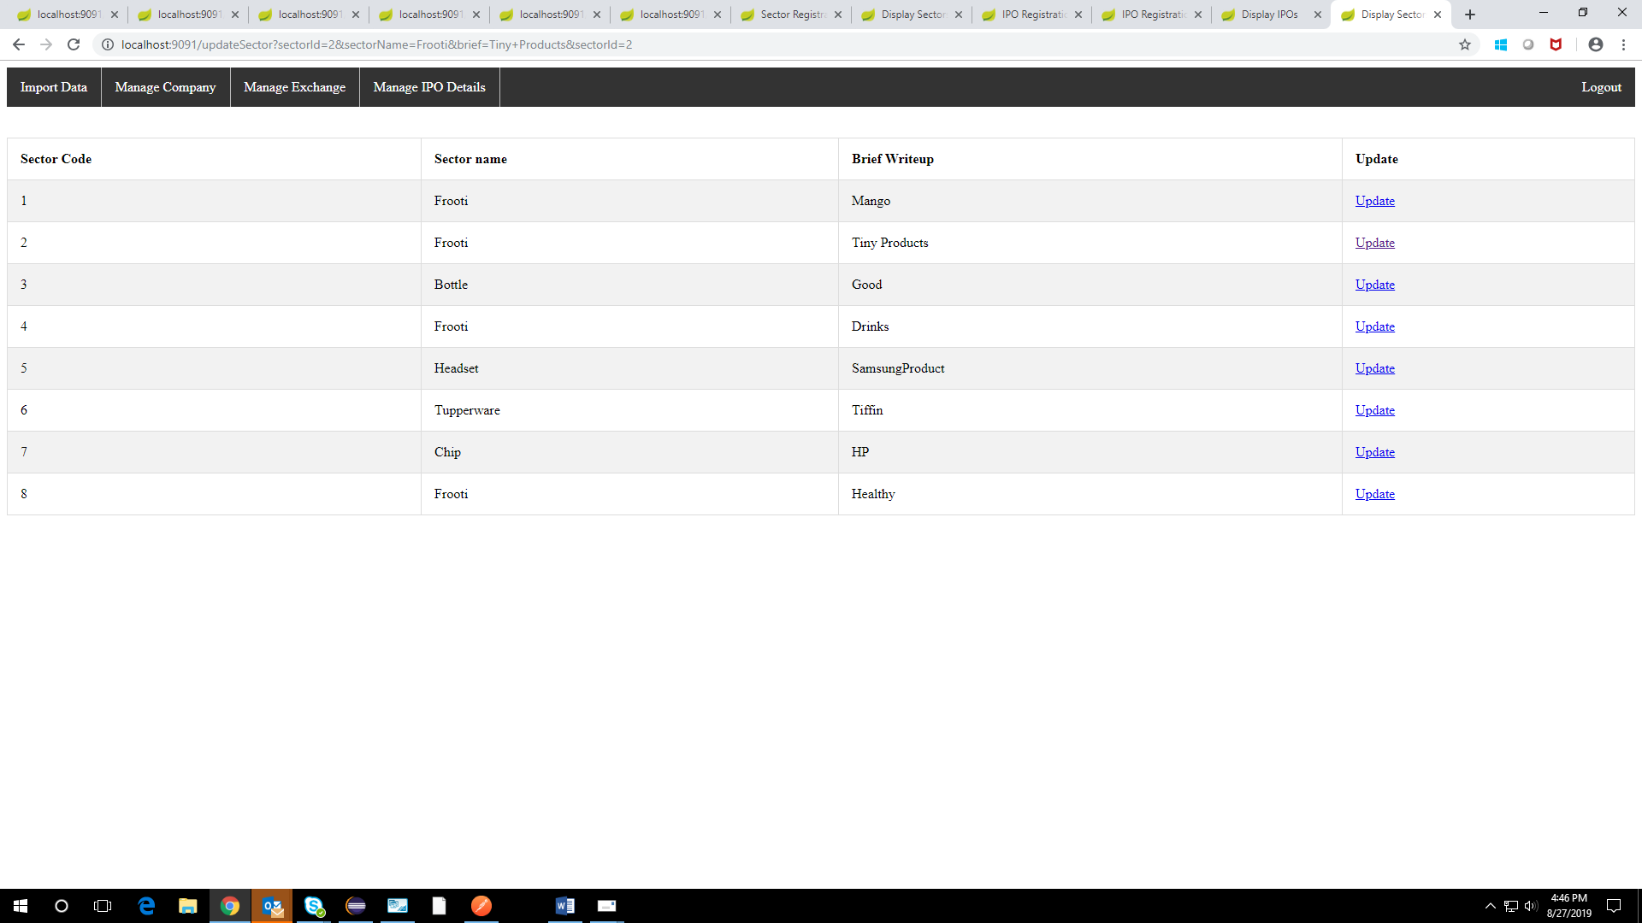

**UPDATING SECTOR DETAILS:**

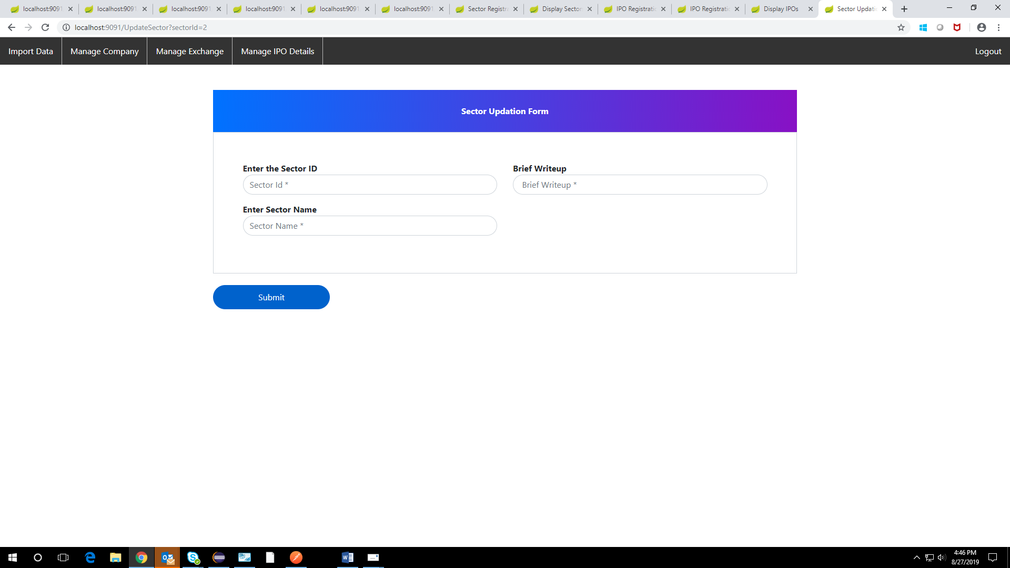

**REST CONTROLLER**

**DISPLAYING IPO DETAILS BY COMPANY CODE:**

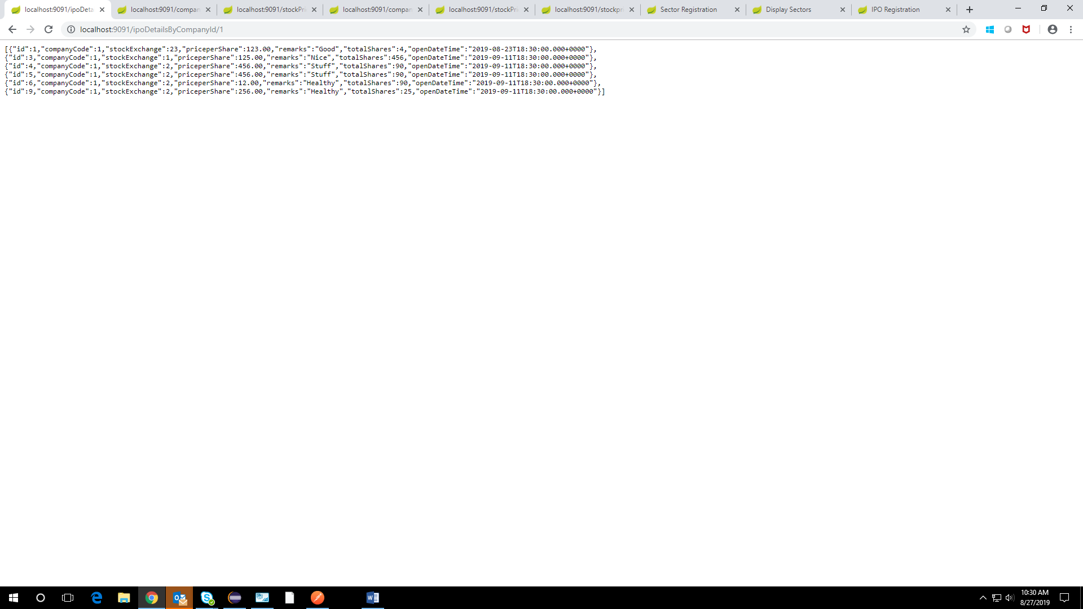

**DISPLAYING COMPANY DETAILS BY SECTOR ID:**

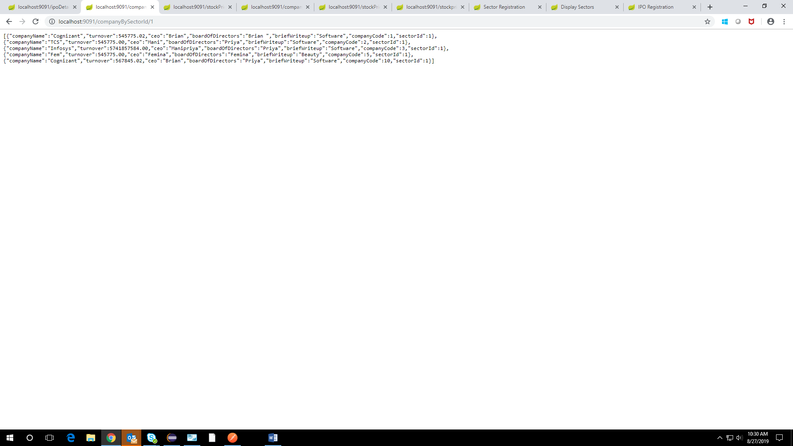

**STOCK PRICE BY COMPANY CODE WITHIN A DURATION:**

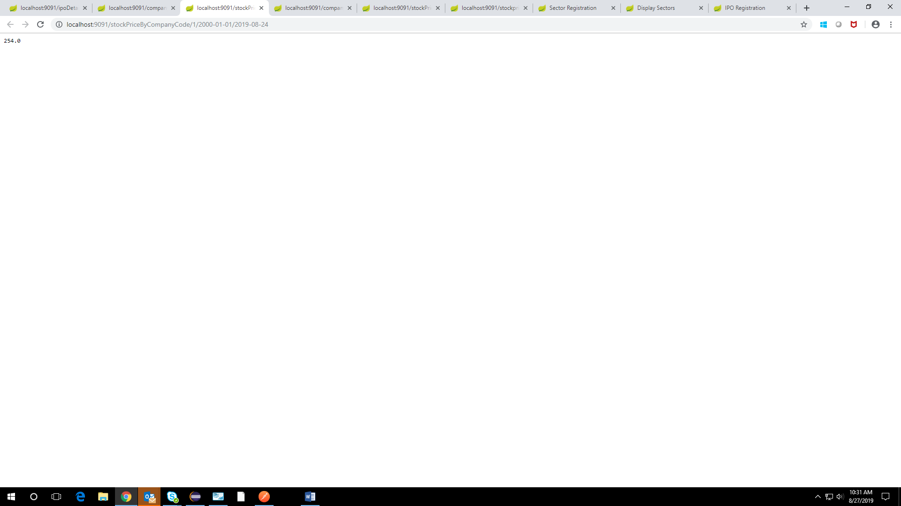

**DISPLAYING COMPANY BY A LETTER(PATTERN):**

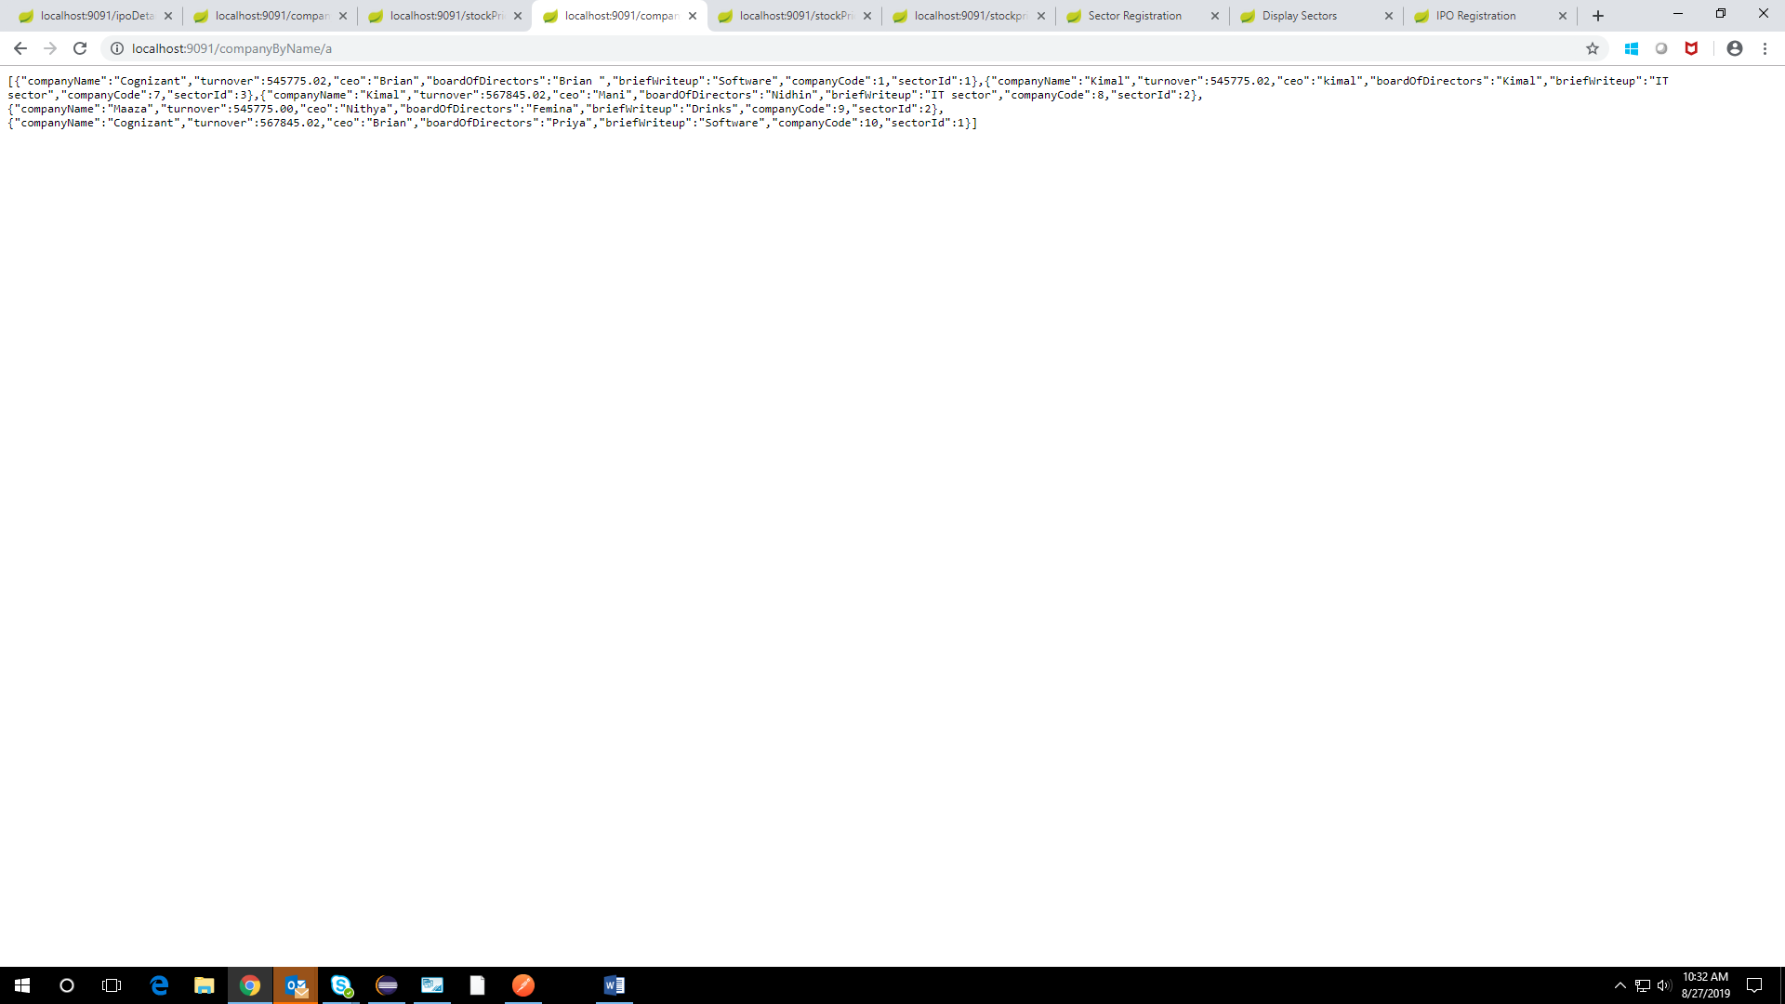

**STOCK PRICE DETAILS BY COMPANY CODE:**

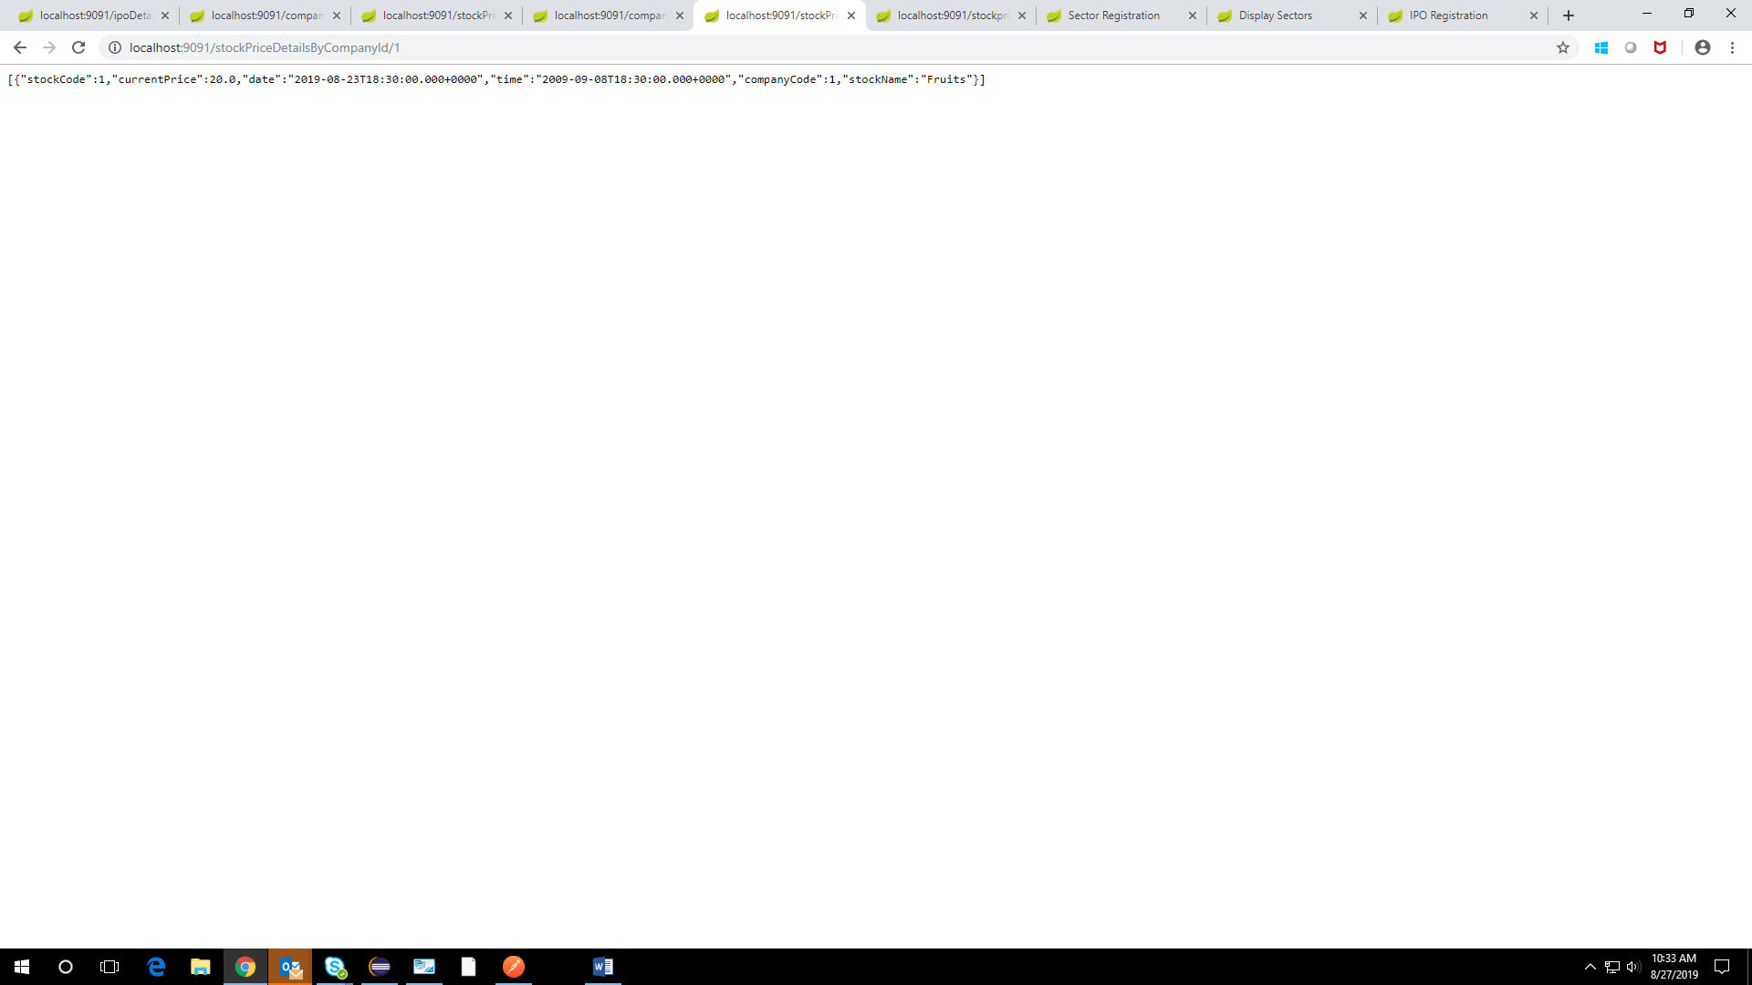

**STOCK PRICE DETAILS WITHIN A DURATION:**

